**Progress until 2/14/2010**

**Action Items:**

* Resolved all linking errors with simulation.
* Resolved issues with interface links, all good now.
* Fixed up documentation to be up to date with current progress.
* Discovered that IPv6 R&D License had expired in December.
* Fixed some potential bugs in the tunneling code.
* Added debugging tests
* Fixed settings parsing in MAP Ad Generator.
* Fixed bug in Ad Generator timing.
* Fixed bug in ipv6 header creation.
* Added proper registration with ip_dispatch so packets are recognized.
* AD packets getting clobbered by ip_dispatch, currently looking into it.

**sim.tif**

**Progress until 2/01/2010**

This week I expanded more on the Hierarchical Mobile IP version 6 work, I added a Mobility Anchor Point advertisement module that simply advertises the MAP’s address from the access points every second.

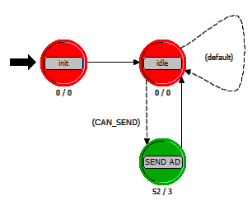

Figure : MAP Advertisement Process

After this module was complete I was able to start back on setting up the Regional Care Of Address generation code in the Mobile Node process.

After talking to Hasan at last week’s research meeting he realized that the majority of the code between the HMIPv6 and PMIPv6 elements will be the same or at least very similar. With exception to the actual Proxy entity and some other loose strings. Given the similarities, it would be useful for both of Qin Bin Chen to be able to get you up to speed on what I've done so far.

The rest of the week was spent documenting and cleaning up my code so that Qin Bin Chen could leverage my work so far. I set up a repository so we can share code back and forth <http://github.com/bgianfo/opnet-hmipv6>. On Friday I came in and sat with Qin while he read over some of the code, answering any questions he had along the way. He didn’t seem to have many problems he was mostly just trying digest the large pile code I had dumped in front of him.

**Progress until 1/25/2010**

Continued on with the ongoing HMIPv6 implementation, I finalized all parts of the MAP server and moved on to the Mobile Node, implementation. I have most of the mobile node code fleshed out. The only large part left is figuring out how to generate the suggested regional care of address that the Mobile Node sends to the MAP in the bind update. Hasan gave me some insight into this area, I’m currently looking through the RFC 2462 on”IPv6 Stateless Address Auto configuration”. Once this piece comes together I am hoping with some debugging that the implementation will be complete and we can start running numbers.

**Progress till 1/17/2010**

Continued HMIPv6 work, this week I mainly focused on modeling the HMIPv6 MAP.

This week I went through the HMIPv6 RFC and picked out the sections describing the interactions between the MAP entity and the HMIPv6 Mobile Node. I then went through and took out pieces that we didn’t need for our study. Hasan and I later went over this to make sure I didn’t forget or remove something we actually did need. This has been a useful guide for what I actually do have to implement.

**MAP Operations:**

1. Receive BU’s, add to bind cache and send a BAck.
2. Intercept packets addressed to RCoA and tunnel them to the LCoA.

**Mobile Node Operations:**

1. Setup LCoA and RCoA
2. Send BU to MAP with both addresses
3. Receive Back.
4. Interact with nodes outside MAP through tunnel with MAP.

The strategy I have taken to implementing HMIPv6 is to implement the MAP and HMIPv6 MN as simple process models which can be attached to the IP stack of any existing Node Models. Hasan agreed that this was a decent way to approach the implementation. I took this idea from the previously mentioned master’s thesis, “Performance Evaluation of IPv6 Mobility Schemes”.

**Node Models:**

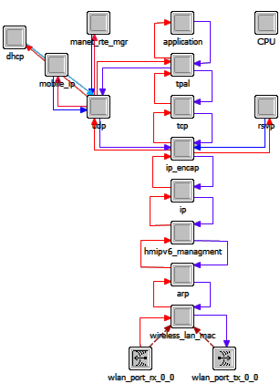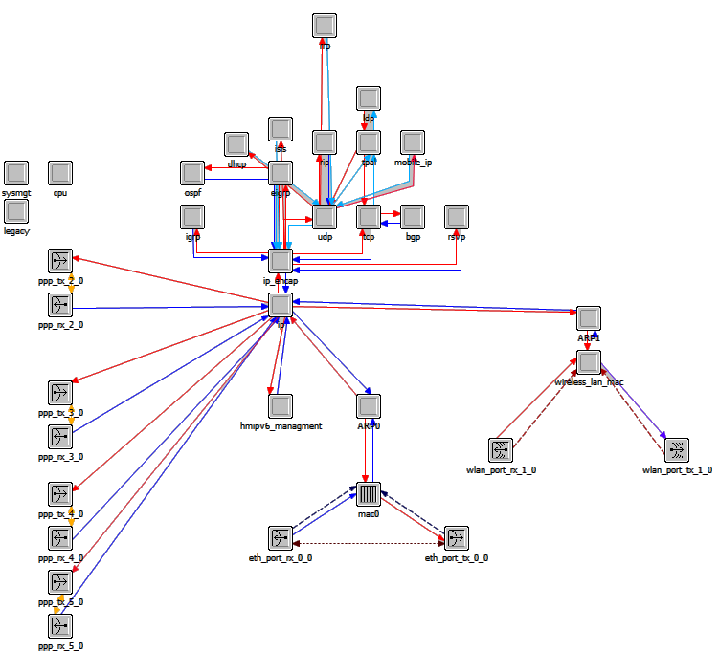

Figure : Mobile Node

Figure : Mobility Access Point

**Process Models:**

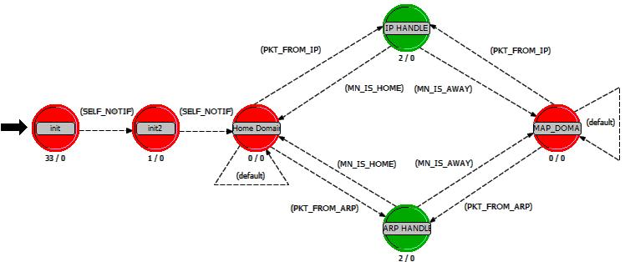

Figure : Mobile Node

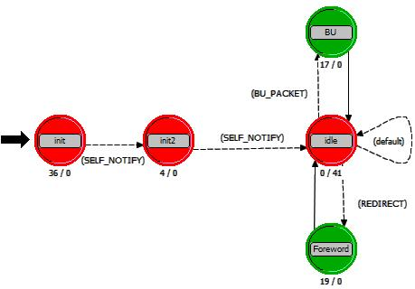

Figure : MAP

Currently the MAP is about 90% implemented; the rest depends on interactions with the Mobile Node. I’m starting to switch over to implementing the Mobile Node so these interactions can be finalized. The progress so far has been fairly rough, using OPNET’s MIPv6 implementation as a guide. Everything is abstracted in function calls nested many levels deep, using shared memory between nodes, regular packets and ICI’s. I feel like I’m starting to get a decent global picture of how it’s all supposed to work as I keep looking deeper and deeper, but progress so far has been as much learning as it has been implementing the protocol.

**Progress till 1/09/2009**

Continued working heavily on the HMIPv6 implementation for OPNET.

Working on add on MAP and Mobile Node modules which will interface with OPNET’s existing MIPv6 infrastructure.

Found another paper and a master’s thesis on Implementing HMIPv6 in OPNET.

I have contacted all the others of “**Micromobility Management Enhancement for**

**Fast Handover in HMIPv6-Based Real-Time Applications*”*** with no response. I also contacted the advisor of the Kenneth K. Svendsen’s Master’s Thesis “Performance Evaluation of IPv6 Mobility Schemes” with no response. After a lot of digging I found an actual email address for Kenneth and have emailed him, eagerly awaiting a reply.

The master’s thesis has a lot of useful information on his implementation and is a great outline for the tasks that need to be done to implement HMIPv6.

I feel that having this paper as an outline I’ve made significant progress already and hope that things will progress much faster with something to give me my bearings.

**Progress till 12/18/2009**

Continued work on MIPv6 simulation, and eventually came to a relatively good stopping point for now with the simulation. Hasan advised me to start looking into HMIPv6 for the next simulation. I read through Hasan’s overview of HMIPv6 and several papers on it’s operation as well as several parts of the HMIPv6 RFC (5380). I started looking around for existing HMIPv6 implementations in OPNET. Hasan pointed me to one paper “A New Implementation of HMIPv6 Protocol on OPNET Modeler 11.5”. After reading the paper I contacted all three of the authors, none of them have responded to my request to use their implementation thus far.

Currently I have been working on Adapting OPNET’s implementation of MIPv6 to HMIPv6 since they are relatively similar. So far this route seems to be working well, It also has the benefit of making me more familiar with the actual underlying implementation of OPNET’s MIPv6 so I can more easily fix any problems with it when I come back to MIPv6.

**Progress till 12/14/2009**

I started this week by reading up on Mobile IP v6 (MIPv6) and trying to understand it full. Hasan provided me with many useful documents describing the protocol and how it is used. After reading these I went on to read the comparison paper, “**A performance comparison of Mobile IPv6, Hierarchical Mobile IPv6, Fast Handovers for Mobile IPv6 and their Combination”**

After reading through the requirements I began building a duplicate model using MIPv6 in OPNET. Currently the model is completely built with the correct network topology as described in the comparison paper. The only problem so far is that no MIPv6 specific traffic is being generated. The network is operational in the simulation but the MN’s don’t seem to be contacting the HA as they should. I am currently putting my full attention into properly configuring the MIPv6 devices correctly. Once this is finished the simulation should be ready.